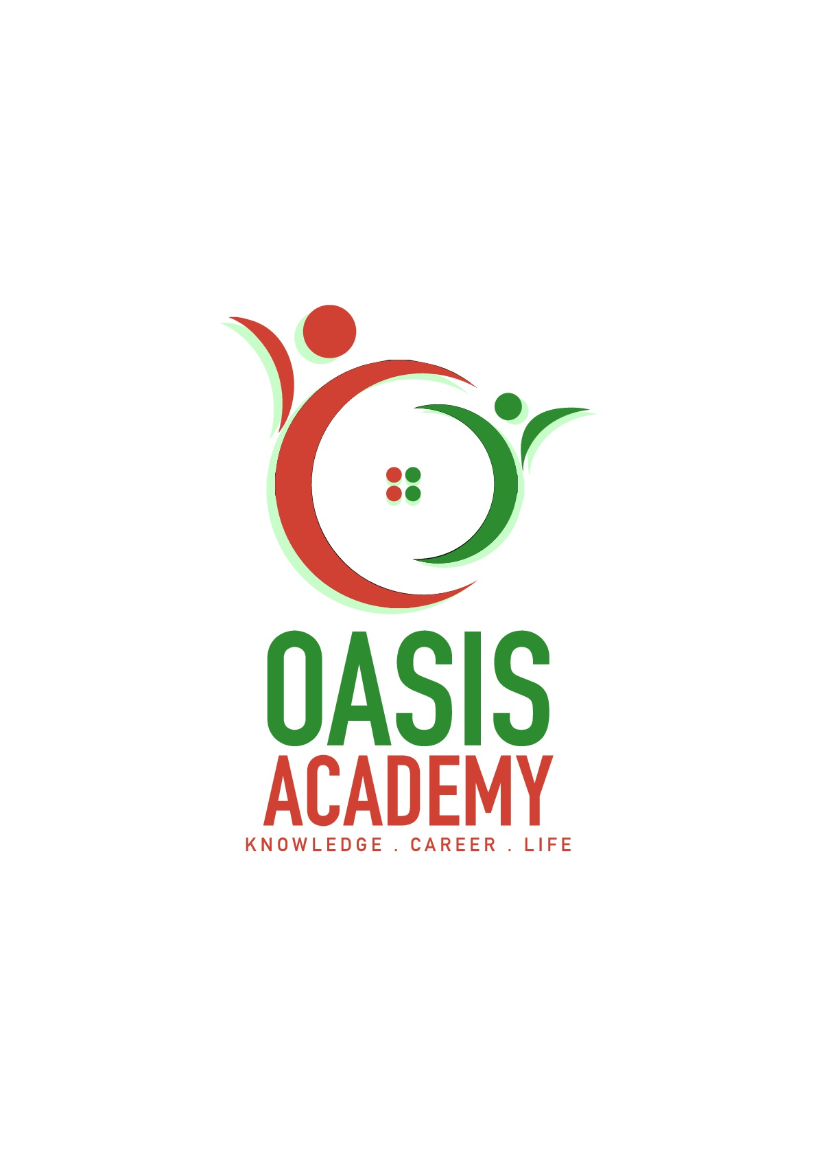

Name: Chee Fui Hlung

Login ID: cheefui@oasis-portal.com

Course title: ESSENTIALS OF HUMAN RESOURCES

Subject Code: BHM01

Submitted date: 5 June 2017

**Table of Contents**

|  |  |  |
| --- | --- | --- |
| **No** | **Details** | **Page** |
| 1 | Executive Summary | 2 |
| 2 | Introduction | 3 |
| 3 | Assignment Question |  |
|  | Part 1 | 4-6 |
|  | Part 2 | 7-10 |
|  | Part 3 | 11-13 |
|  | Part 4 | 14-15 |
| 4 | Conclusion | 16 |
| 5 | References | 17 |

**Executive Summary**

In this assignment I will be explaining about Human Resource Management which is the function within an organization that focuses on the recruitment of management. In the first part. I have understand the definition of major activities of human resource. In the second part, I will briefly on human resources planning and trends in hospitality. Furthermore, I will define my understanding on action plan human resource planning in hotel industry. Thirdly, I will briefly about the human resources functions and human resource policies. Moreover, I will describe the functions of management and how the policy applies accordingly in hospitality management. Lastly, I will explain in detail about organizational behavior in hospitality and briefly on group and structure in organization

**Introduction**

In this assignment, I will be explaining about the Human Resource Management. What is Human Resources Management. Human resource or manpower management effectively describes the process of planning and directing the application, development and utilization of human resources in employment.

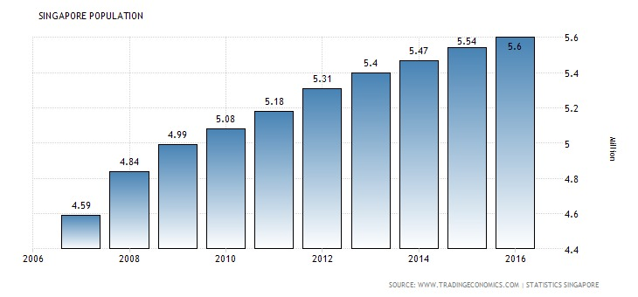

As you can see, the Singapore population has growing well every year. There is a lot of human resources in Singapore.

**Assignment Questions**

**Question 1**

Define the Major Activities and Human Resources Operation in Hospitality Management

**Recruiting**  
Human resource management involves several employee-related some activities of small company. Human resource managers have to find a talented staff to help employees and to ensure their employees are good pain and take care of their management. Human resources manager sometimes will carry out many duties and activities on a weekly.

**Selecting**

Human Resource Management is responsible for selecting staff and hiring candidates. Department managers usually they apprise human resources managers and their qualifications they need to desire in job applicants. They develop job descript that outline various skills and experience levels for applicants. They will places in newspaper or the online job boards to attract the right person of the job of candidates. They will shifts through piles of the resumes and select the most qualified applicants person. They also can screen applicants to weed out people who might not fit into their small organization’s culture.

**Training**

Human Resource Management also will manages new employee to the training. Some training may be involve information training manuals and company policy. In other times , these employees also coordinate the training of existing the staff’s courses , the employee also have to improve the computer skill , writing skills and verbal skills.

**Motivation**

Management and leadership action that empower employees. Treating employees with respect. Minimizing the number of rules and policies in an environment that demonstrates trust for employees and treat employees like an adult. Positively managing employees within a success framework of goals, measurements and clear expectations.

**Evaluation**

The human resource management function has to be able to demonstrate that it adds value to the organization that it is a part of. The framework by which human resource management practitioners are able to evaluate the degree to which their initiatives add value to an organization and aid the strategic planning of human capital for the organisation. The aims of this unit is to understand external and internal organisational environments in shaping the strategic provision of human resource function. The strategic planning approach to human resource functions within organisations, designing human resource programs that are sensitive to political, physical, cultural and cognitive-behavioural considerations, linking training to audience learning styles based on a clear understanding of training techniques, philosophies and technologies, determine cost-benefit analysis of internal versus external provision and manage and evaluate the human resource function with a detailed understanding of methodical and pragmatic considerations.

**Compensation**

The HR department will determines compensation for various employees. Most of the compensation is based on grade levels. The HR manager might have to study comparable salary within the industry to derive their compensation ranges. They must operate within their company budget when the determining salaries, and other incentives. HR managers know they have to offer competitive salary to help to retain their quality workers.

**Question 2**

Describe in brief on Human Resources Planning and Planning Trend in Hospitality.

HR planning systematic analysis HR needs in order to ensure that the right number, right kind of people are available, at the right time, at the right place to do the right job. For the planning trend in hospitality are Outsourcing which is creating talents pools, submitting applicants information according to the need of organization, final selection will be made by organization, have to pay service. Secondly, internship or graduate intake program which is work and study, trainee post after graduation. Next talent pool which is creation database by using information technology, mini recruitments agency and privacy, next, poaching or raiding which is ‘buying talent’ rather than developing it, offering attractive packages and others term and conditions, better than current employer of the candidate, unethical practice and it has become a challenge for human resource managers to face and tackle poaching, as it weakens the competitive strength of the firm. Lastly, e-recruitment which is advertising the vacancies through website, receiving CVs from email, interview process will happen through support of information technology, recruitment of right type of people and low cost.

Explain about what is your understanding on Action Plan Human Resource Planning in Hotel Industry.

Human resources planning assess the manpower requirement for future period of time. It attempts to provide sufficient manpower required to perform organizational activities. HR planning is a continuous process which starts with identification of HR objectives, move through analysis of manpower resources and ends at appraisal of HR planning. The major steps of human resource planning are as follows:

**1. Assessing Human Resources**

The assessment of HR begins with environmental analysis, under which the external (PEST) and internal (objectives, resources and structure) are analyzed to assess the currently available HR inventory level. After the analysis of external and internal forces of the organization, it will be easier for **HR manager**to find out the internal strengths as well as weakness of the organization in one hand and opportunities and threats on the other. Moreover, it includes an inventory of the workers and skills already available within the organization and a comprehensive job analysis.

**2. Demand Forecasting**

HR forecasting is the process of estimating demand for and supply of HR in an organization. Demand forecasting is a process of determining future needs for HR in terms of quantity and quality. It is done to meet the future personnel requirements of the organization to achieve the desired level of output. Future human resource need can be estimated with the help of the organization's current human resource situation and analysis of organizational plans an procedures. It will be necessary to perform a year-by-year analysis for every significant level and type

**3. Supply Forecasting**

Supply is another side of human resource assessment. It is concerned with the estimation of supply of manpower given the analysis of current resource and future availability of human resource in the organization. It estimates the future sources of HR that are likely to be available from within an outside the organization. Internal source includes promotion, transfer, job enlargement and enrichment, whereas external source includes **recruitment of fresh candidates**who are capable of performing well in the organization.

**4. Matching Demand And Supply**

It is another step of human resource planning. It is concerned with bringing the forecast of future demand and supply of HR.The matching process refers to bring demand and supply in an equilibrium position so that shortages and over staffing position will be solved. In case of shortages an organization has to hire more required number of employees. Conversely, in the case of over staffing it has to reduce the level of existing employment. Hence, it is concluded that this matching process gives knowledge about requirements and sources of HR.

**Question 3**

Brief about Human Resources Functions and Human Resources Policies.

Development, Organizations must outfit operators with the contraptions basic for their prospering which, things being what they are, gathers giving new experts wide colleague arranging with help them move into another dynamic culture. Different HR work environments in like way give association prepare and able progress. Authority arranging might be required of starting late contracted and pushed chiefs and executives on centers, for example, execution association and how to oversee assign relations matters at the working environment level. Fit change openings are for workers examining for phenomenal open portals or operators who need to satisfy solitary objectives, for example, completing a specialist guideline. Wanders, for example, informative cost help and educational cost repayment programs a significant part of the time are inside the region of the HR prepare and movement zone.

Worker Relations, In a unionized workplace, the pro and work relations segments of HR might be hardened and overseen by one master or be all around free points of confinement controlled by two HR specialists with particular strength in each range. Designate relations are the HR get ready worried with fortifying the business pro relationship through measuring work fulfillment, specialist engagement and settling working environment fight. Work relations cutoff points may combine making association reaction to union managing battles, engineering complete overseeing verifications and rendering translations of worker's affiliation contract issues.

Staffing, The achievement of scouts and work masters generally speaking is measured by the measure of positions they fill and the time it takes to fill those positions. Enrollment specialists who work in-house - instead of affiliations that give picking and staffing associations - acknowledge a key part in working up the business' workforce. They propel work postings, source hopefuls, screen candidates, organize preparatory social affairs and mastermind using tries with executives in charge of settling on the last determination of contenders.

Safety, Working condition security is a fundamental variable. Under the Word related Prosperity and Prosperity Exhibition of 1970, associations have a promise to give a secured workplace to delegates. One of the standard segments of HR is to bolster work environment security arranging and keep up authoritatively summoned logs for work space insidiousness and misfortune determining. In like way, HR thriving and hazard masters a great part of the time work by and by with HR benefits specialists to deal with the affiliation's laborers pay issues.

Compensating, Human asset work oblige gives a sensible method to picking how much operators ought to be paid for playing out specific occupations. Pay is unmistakably identified with the upkeep of HR. Since pay is a huge cost to different affiliations, it is a basic idea in human asset organizing. Pay impacts staffing in that individuals are by and large maneuvered into affiliations offering a greater measure of pay as a final product of the work performed. It is identified with operator progress in that it gives a basic boost in persuading authorities to greater measures of occupation execution and to higher paying organizations in the alliance.

**Question 4**

Explain in detail about Organizational Behavior in Hospitality and brief on Group and structure in Organization.

Organizational behavior is a use of learning about human conduct in associations as it identifies with other framework components, for example, structure, innovation and the outside social framework. Organizational structure is a framework that comprises of unequivocal and certain institutional tenets and approaches intended to diagram how different function parts and duties are designated, controlled and composed. Organizational structure likewise decides how data streams from level to level inside the organization. For instance, in a brought together structure, choices spill out of the top down, while in a decentralized structure, the choices are made at different diverse levels.

​Four sorts of basic hierarchical structures are executed in this present reality. The to start with, and most normal, is a practical structure. This is likewise alluded to as a bureaucratic authoritative structure and separates an organization in light of the specialization of its workforce. Most little to-medium measured organizations actualize a useful structure. Separating the firm into offices comprising of advertising, deals and operations is the demonstration of utilizing a bureaucratic authoritative structure.

The second sort is regular among huge organizations with numerous specialty units. Called the divisional or multi-divisional structure, an organization that uses this technique structures its initiative group in view of the items, activities or auxiliaries they work. A decent case of this structure is Johnson and Johnson. With a large number of items and lines of business, the organization structures itself so every specialty unit works as its own organization with its own particular president.

The third sort and is utilized among numerous new businesses. As the name implies, it smoothest the order and hierarchy of leadership and gives its representatives a great deal of self-rule. Organizations that utilization this sort of structure have a rapid of usage.

The fourth and last hierarchical structure is a lattice structure. It is likewise the most confounding and the slightest utilized. This structure networks workers crosswise over various bosses, divisions or offices. A worker working for a matrixes organization, for instance, may have obligations in both deals and client benefit.

**Conclusion**

In this assignment I learn about the first thing is the six major of human resources which is recruitment, selection, training, motivation, evaluation, compensation. In recruitment I think is very important. Because the main reason is to find the most suitable candidates for the company, and they help to achieve the company’s goals. The recruitment process is important and can’t make any mistakes. They need to determine candidate their skill and abilities suitable for the company’s position. Organizational behavior is especially important in the field of management, because to the fact that it have many of the problem managers face on basic daily. Such as like leadership, team building, motivation and job satisfaction are all face on responsibility of management.

**References**

# Name: Rick Suttle

# Published date : 18 May 2017

# Book title: Major Categories of HR Management Activities

* <mailto:http://smallbusiness.chron.com/seven-major-categories-hr-management-activities-37354.html>

THE END